TPS Community History Summer Workshop
Bradley University
June 18, 20, 29, and 30, 2012

Bio Poems
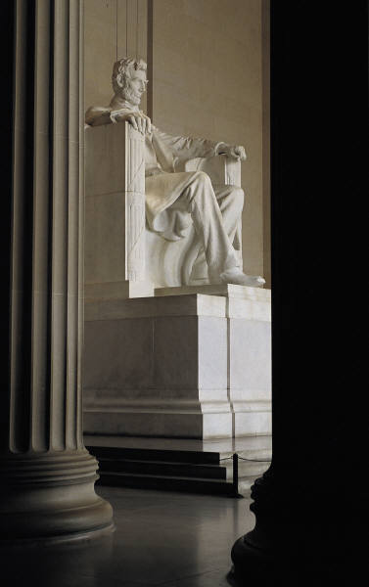
Bio-Poems used for descriptive and efferent writing.
Library of Congress Primary Sources www.loc.gov
Background and Overview: Bio-Poems do not contain rhyme and are based on biographies or autobiographies.
Objective: Students will read a section of Library of Congress about a famous person from history. Students will create a bio-poem based on details and characteristics of the famous person and organize details of information to write a summary.
Pattern for Use:
Line 1- Write the first name of the famous person.
Line 2- Write three or four words that describe the famous person.
Line 3-Where was the famous person born?
Line 4-Describe the time period in which he or she lived.
Line 5- Name a family member and their relationship to the famous person.
Line 6-How does the person feel in life? Name three feelings.
Line 7-Name three things the famous person tried to accomplish.
Line 8-Name three important accomplishments.
Line 9-How is the famous person best known in history?
Line 10- Write the last name of the famous person.
Assessment
 | Beginning | Developing | Proficient
Famous Figure | Reference is made to famous person with little or no description. | Famous person is briefly described, with traits mentioned. | Famous person is described, clearly relating character traits to life events.
Life Events | One or two life events are mentioned. | Some life events are mentioned. | Life events are clearly described.
LOC Website | Student had difficulty finding answers to the questions on the LOC website. | Student found most answers to the questions on the LOC website. | Student successfully navigated the LOC website.
Poem | Student did not answer all questions and did not finish the Bio Poem. | Student answered at least eight questions for the Bio Poem. | Student answered all of the questions and completed the Bio Poem.
Summary | The summary was incomplete and few details. | Summary contained most of the identified information. | Summary was concise and factual.
Spelling | Many spelling errors appear; misspelled words are not aligned to standard spelling. | Few spelling errors. | No spelling errors.

Resources
Antonacci, P. A. & O'Callaghan, C. M. (2006) Literacy instructional & assessment strategies K-8. Pearson,Allyn and Bacon.

Library of Congress (2006). [On-line]. Available www.loc.gov
Norton, T. & Land, B. L. J. (2008). 50 literacy strategies for beginning teachers, 1-8 (2nd ed.). Upper Saddle River, NJ: Pearson Education, Inc.

