TPS Community History Summer Workshop
Bradley University
June 18, 20, 29, and 30, 2012

Touring Peoria’s Past

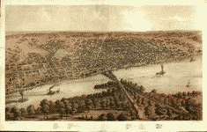

GAR Hall
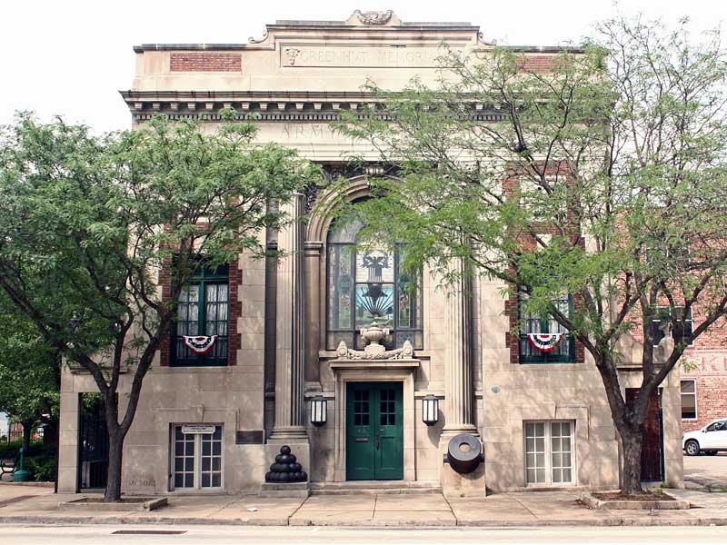
416 Hamilton Blvd in Peoria, Illinois
The Grand Army of the Republic GAR Hall was a gathering place for veterans. General John “Black Jack” Logan organized the Grand Army of the Republic as a veterans’ organization. The hall was dedicated in 1909 and has been listed on the National Register of Historic Places since 1976.
GAR Hall - Visual Literacy Questions
Asking questions about a visual provides opportunities to analyze information and connect critical thinking skills which can be used for further research. Look for answers to these questions as you tour the historic places of Peoria’s past:
As you approach the building, what do you see? Is there anything unusual about the building?

What caught your attention first? What is the focal point?

Did the building evoke any emotions?

What cultural influences do you see?

What is the time period of the building?

As you look at the building, does it tell a story?

Is this an important building? Why is it important?

Identify a unique artifact inside the building. Why is it unique?

Was the artifact directly related to the owner or founder? What is the relationship of the artifact to the owner, founder, or building?

Summarize your observations.

Old Peoria and Judge Tour
Leave from Kelleher’s at 619 S.W. Water Street, Peoria, IL 61602
French explorer Henri de Tonti established a fort in 1691, the first settlement in Illinois. The tour will cover the earliest sections of downtown Peoria and its Northside.
Flanagan House
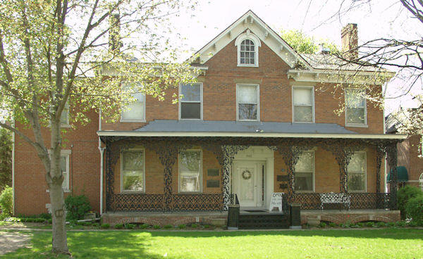
942 NE Glen Oak Avenue, Peoria, IL 61603
The John C. Flanagan House was built in 1837 on Peoria’s east bluff. Built by John C. Flanagan, a prominent judge in Peoria, it is the oldest standing house in Peoria, Illinois. It was crafted in the American Federal style and is listed on the National Register of Historic Places. It is owned by the Peoria Historical Society and it is also the headquarters of the (DAR) Daughters of the American Revolution, Peoria Chapter. (Peoria Historical Society, 2012)
Flanagan House - Visual Literacy Questions
Asking questions about a visual provides opportunities to analyze information and connect critical thinking skills which can be used for further research. Look for answers to these questions as you tour the historic places of Peoria’s past:
As you approach the building, what do you see? Is there anything unusual about the building?

What caught your attention first? What is the focal point?

Did the building evoke any emotions?

What cultural influences do you see?

What is the time period of the building?

As you look at the building, does it tell a story?

Is this an important building? Why is it important?

Identify a unique artifact inside the building. Why is it unique?

Was the artifact directly related to the owner or founder? What is the relationship of the artifact to the owner, founder, or building?

Summarize your observations.

Pettengill-Morron House
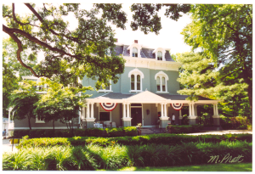
1212 W. Moss Avenue, Peoria, Illinois 61606
The Pettengill-Morron House Museum was built by Moses Pettengill in 1868 in the Second Empire architectural style. In 1966 the house and its contents were given to the Peoria Historical Society. (Peoria Historical Society, 2012)
Pettengill-Morron House - Visual Literacy Questions
Asking questions about a visual provides opportunities to analyze information and connect critical thinking skills which can be used for further research. Look for answers to these questions as you tour the historic places of Peoria’s past:
As you approach the building, what do you see? Is there anything unusual about the building?

What caught your attention first? What is the focal point?

Did the building evoke any emotions?

What cultural influences do you see?

What is the time period of the building?

As you look at the building, does it tell a story?

Is this an important building? Why is it important?

Identify a unique artifact inside the building. Why is it unique?

Was the artifact directly related to the owner or founder? What is the relationship of the artifact to the owner, founder, or building?

Summarize your observations.

Resources
Hirshfield, N. (2009). Teaching cops to see. Smithsonian, 40 (7), 48-52, 54.
Newman, M., Sheridan, K., & Ogle, D. (2009). Visual literacy curriculum. In Teaching with
primary sources: Collected works, 2, 49-54.
Pardieck, S. C. (2011-2012). Visual literacy: Reading and analyzing e-primary sources. Illinois
Reading Council Journal, 40 (1), 28-32.

